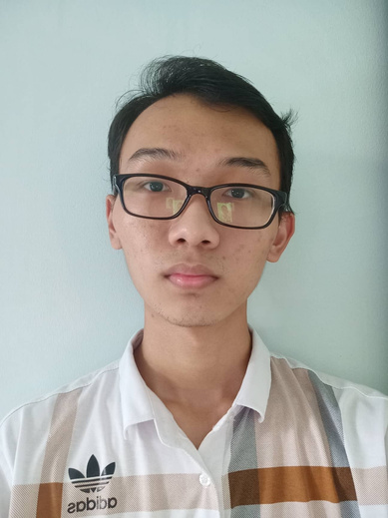 | LAI YOKE YAU  DATA SCIENCE MAJOR — TUNKU ABDUL RAHMAN UNIVERSITY OF MANAGEMENT AND TECHNOLOGY

SUMMARY  Data Science student who considers themselves someone who highlights teamwork, problem-solving, time management, and adaptability.  Aspiring Data Engineer & AI Workflow Engineer | Experience in Python, SQL, AWS Cloud, n8n, and Claude Code. |  | CONTACT  Phone: +6018-3822330  Email: laiyokeyau@gmail.com  Address: 5, Jalan Saujana 13A, Taman Ampang Saujana, 68000 Ampang, Selangor.  LinkedIn: linkedin.com/in/yoke-yau-lai
EDUCATION
Degree in Data Science, Tunku Abdul Rahman University of Management and Technology June 2024 – In progress
CGPA: 3.77
- Dean's List: 2 semesters; President's List: 1 semester
- Participated in the 2025 DevMatch Hackathon, The 2025 Great Malaysia AI Hackathon, and Cursor Hackathon
- Achieved First Runner-Up at ISEK.AI ACG Hackathon (2025)
- Achieved 2nd Runner-Up at NextUp Hackathon (2025)
Diploma in Computer Science, Tunku Abdul Rahman University of Management and Technology 2022 – 2024
CGPA: 3.8704
- Achieved Gold Award Soft Skills Competency Certificate throughout the whole Diploma
- Organised Peer Support Society's Fund Raising (2022) and Diabolo Festival (2023)
- Took part in Pra-kelayakan IT Network Systems Administration, WorldSkills Malaysia Belia 2024 Competition
SMK Taman Seraya 2016 – 2022
SPM Result: 1A+ 3A 1A- 4B+ 1C+
WORK EXPERIENCE
Product Developer, Super Products Jan 2026 – Present
Daily work outside of training sessions. Intern as a product developer.
- Developed the SuperHomes.my website using Claude Code; set up and maintained the hosting server.
- Helped debug and implement features in SuperAgentK, including multiple mini-apps within the product.
AI Training Facilitator, AITraining2U PLT Jan 2026 – Present
Training company providing AI-related training to the public and companies. Intern as a facilitator.
- Conducted and facilitated AI training sessions for corporate clients, providing logistics and technical support during sessions.
- Shared practical experience using AI and n8n in daily workflows such as product development, helping attendees apply AI tools effectively.
Implementation Consultant, YonYou Malaysia Sdn Bhd Nov 2023 – Jan 2024
ERP company selling its own ERP system and providing customization services. Intern as an implementation consultant.
- Delivered customer service and after-sales support, providing solutions based on issues clients faced using the product.
- Summarized meeting minutes to conclude requirements gathered from clients.
Data Entry Clerk / Technical Support, Greenomic Commerce Sdn Bhd Jan 2021 – Present
- Listed and maintained product entries across e-commerce platforms including Lazada and Shopee, ensuring accurate and up-to-date catalogs.
- Produced product images and video edits to support listing quality, gaining hands-on exposure to end-to-end e-commerce operations.
- Provided technical support on the Gundam.my e-commerce website, including API integrations across Shopee, Lazada, and TikTok.
- Integrated payment gateway APIs, including iPay88 and gKash, into the Gundam.my e-commerce website.
- Fixed bugs on the live site and implemented e-invoice features to support compliance and order processing.
SKILLS
Python — Intermediate  SQL — Intermediate  AWS Cloud — Intermediate  Java — Intermediate  Additional: JavaScript, C, HTML/CSS, Pandas, NumPy, Excel, n8n, Claude Code, MCP, React.js, FastAPI, Streamlit, Git, Jupyter Notebook, Microsoft Office |  | LANGUAGE  Mandarin — Speaking: Advanced, Writing: Advanced  English — Speaking: Intermediate, Writing: Advanced  Malay — Speaking: Advanced, Writing: Advanced  Japanese — Speaking: Beginner, Writing: Beginner
CERTIFICATION AND BADGES
Cloud Foundations | Training Badge  AWS Academy  Soft Skills Competency Certificate | Gold Award  Tunku Abdul Rahman University of Management and Technology  MUET | Band 4  Tunku Abdul Rahman University of Management and Technology  Introduction to Model Context Protocol  Anthropic  AI Fluency for Students  Anthropic |  | Claude Code in Action  Anthropic  Introduction to Claude Cowork  Anthropic  Professional AI Engineering Vibe Coding  Anthropic  AWARDS  First Runner-Up (2025) — ISEK.AI ACG Hackathon  2nd Runner-Up (2025) — NextUp Hackathon
PROJECTS
Client Portal Redesign — IMAX Financial Sdn Bhd
Freelance WordPress website redesign and development.
Redesigned the company's site from a static website into a dynamic one, adding WhatsApp chat integration and additional interactive functions such as a Money Personality Quiz page and a Retirement Calculator.
Video Translator
Hobby project.
A website that translates videos into another language, built for fun.
Cards Against Redditors
Personal project.
A real-time multiplayer game where players weaponise actual Reddit comments to win debates.

